Ubuntu + InfluxDB + Grafana

1. Download and setup Ubuntu
   1. <https://www.ubuntu.com/download/server/thank-you?country=NZ&version=18.04&architecture=amd64>
   2. Setup with ubuntu-18.04-live-server-amd64.iso
   3. GUI install  
      sudo apt-get install python-requests  
      sudo apt-get install ubuntu-desktop
2. Install InfluxDB
   1. wget <https://dl.influxdata.com/influxdb/releases/influxdb_1.5.2_amd64.deb>  
      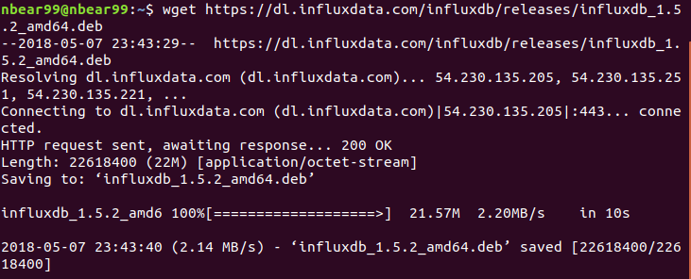
   2. sudo dpkg -i influxdb_1.5.2_amd64.deb  
      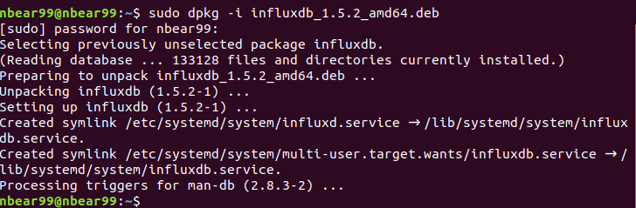
3. Install Grafana
   1. wget <https://s3-us-west-2.amazonaws.com/grafana-releases/release/grafana_5.1.0_amd64.deb>  
      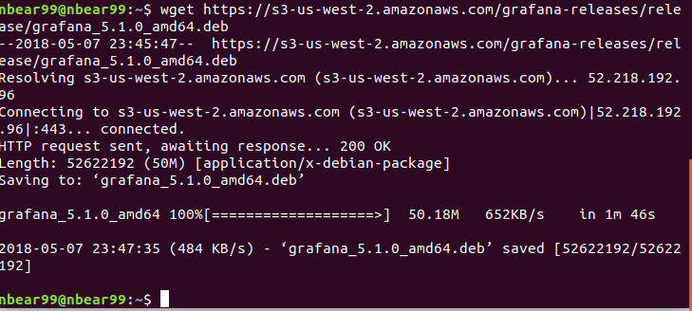
   2. sudo dpkg -i grafana_5.1.0_amd64.deb  
      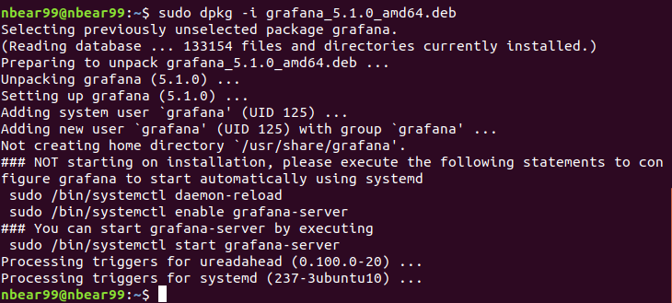
4. Start server services (run every time after rebooting)
   1. sudo service influxdb start  
      
   2. sudo service grafana-server start  
      
5. Import data from csv to influxdb (only Box_ID, Temperature and Time_received fields)  
   You should check CSV file name
   1. wget <https://raw.githubusercontent.com/fabio-miranda/csv-to-influxdb/master/csv-to-influxdb.py>   
      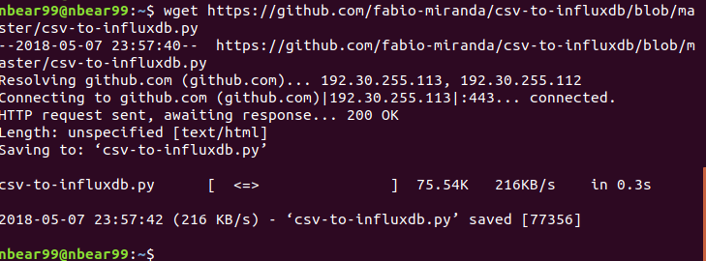
   2. sudo apt-get install python-influxdb  
      
   3. python csv-to-influxdb.py --dbname statsdemo --input Downloads/log.csv --tagcolumns "Box_ID" --fieldcolumns "Temperature" --timecolumn "Time_received" --timeformat "%Y-%m-%d %H:%M:%S"
6. Make graphs on web-browser
   1. Open <http://127.0.0.1:3000> and login

ID: admin, Password: admin  
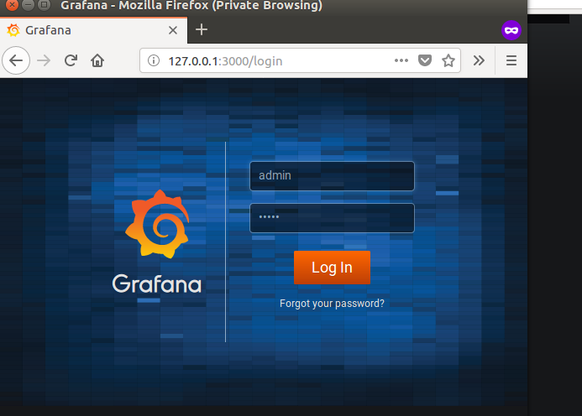

* 1. Click “Add data source”

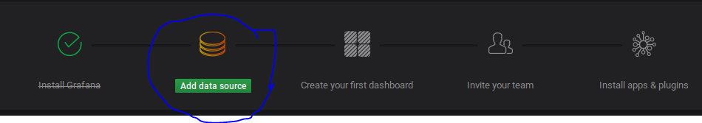

* 1. Fill and choose as bellows to use Data Source

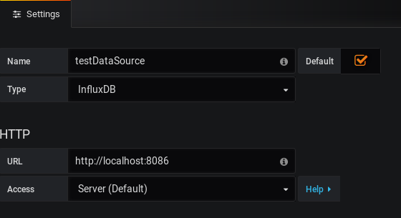  
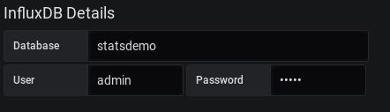  
ID: admin, Password: admin  
  
Click “Save & Test”



* 1. Create Dashboard  
     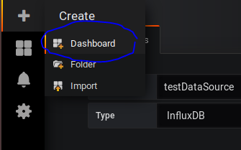  
     Click Graph  
     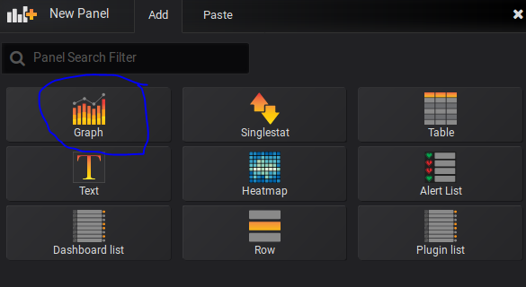  
     Click Panel Title and Edit  
     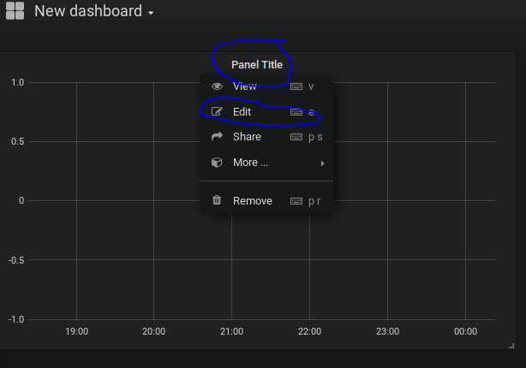  
     Click Menu and Toggle Edit Mode  
       
     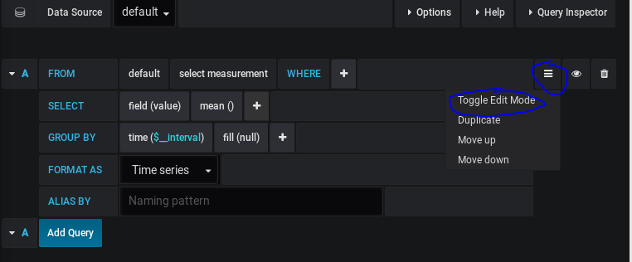  
     Put queries in the boxes

|  |
| --- |
| SELECT mean("Temperature") FROM value WHERE Box_ID = '8' AND $timeFilter GROUP BY time($__interval) fill(null)  SELECT mean("Temperature") FROM value WHERE Box_ID = '100' AND $timeFilter GROUP BY time($__interval) fill(null)  SELECT mean("Temperature") FROM value WHERE $timeFilter GROUP BY time($__interval) fill(null) |

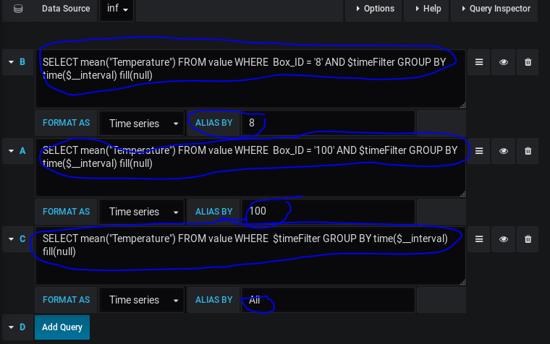  
Click the date and put dates. Lastly apply  
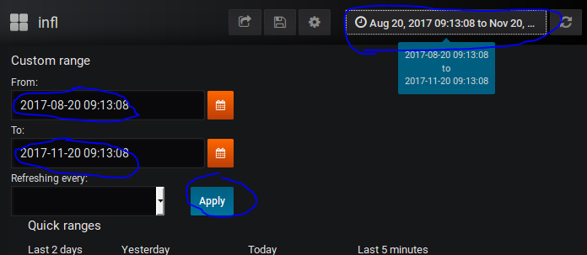

* 1. Check graph  
     